INFORMATION PACKAGE 2020-2021

What is Beyond Me?

London Beyond Me is a student-run non-profit organization out of London, Ontario with a mandate to provide a fun and flexible one-on-one mentoring program for children and teenagers with special needs. Beyond Me originated in Montreal, Québec and has been operating as an organization since 2011. The Montreal organization has grown rapidly and now receives referrals from five schools or organizations – École Peter Hall (both Ouimet Elementary School and Cote Vertu High School), Summit School, the Mackay Centre, the Montreal Oral School for the Deaf (MOSD) and Miriam Home. Beyond Me gives students with special needs an opportunity to be paired up with a student volunteer from the London based area to act as a mentor, tutor, or a friend and to develop a rewarding relationship! Beyond Me volunteers have a diverse set of skills, experience and interests, which allows Beyond Me to match volunteers with buddies who share their interests and who would most benefit from working with that volunteer.

All children in the program are matched up with a student volunteer for one-on-one interaction throughout the year. The relationship between a buddy and volunteer can take on many forms, including subject specific tutoring, homework help, language and play stimulation, social skills building through a social relationship, fun outings in the community, and short-term respite care for parents. The nature of a mentor and a buddy’s relationship and the location of their meetings are flexible and completely dependent on the needs of the child and their parent or guardian.
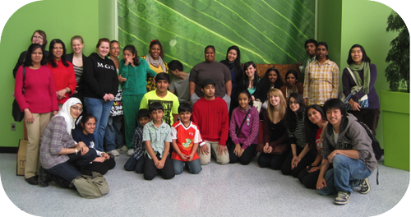

Beyond Me Mentors, Buddies, and Parents during an outing to the Biodome (Montreal Beyond Me)
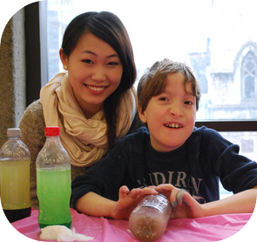
At our inception, Beyond Me started with a mandate to make a positive impact on children with special needs through one-on-one mentorship and organized group events. The organization envisioned the provision of a system that could provide the children in our program with role models, mentors, and friends in an environment that facilitates social development. Beyond Me has evolved to become an all-encompassing organization defined by our five-point mandate, the “Five E’s Approach:”
Engage Youth and Families, through the provision of inclusive activities and events for children with special needs, their family members, and London students.
Empower Self-Growth, through the creation of an environment where children with special needs can gain confidence, independence, and skills that will last beyond the length of the mentorship.
Encourage Communication by acting as a bridge between the mentor, the mentee, their families, and the partner schools, to facilitate the development of meaningful relationships.
Enhance Perceptions by breaking down misconceptions and emphasizing the similarities between individuals and the ability within disabilities as we build relationships.
Experience Community through providing an opportunity for both the mentor and the mentee to be active members of the London community.

How are volunteers screened and matched?

All of the volunteers who join the Beyond Me program go through a screening process before they are able to be matched with or start working with a child in the program.

First, volunteers complete an exhaustive application form and provide details on their prior experience working with children, prior experience working with children or adults with disabilities, their hobbies, interests and special skills, and their comfort level working with individuals with disabilities (for example, whether or not the volunteer is comfortable working with a child who is non-verbal). All of these answers are used later in the process to assist in matching the volunteer with a child. During this application stage, volunteers are also screened based on their responses to questions about the reason for their interest in volunteering with the program and what will make them a good mentor for Beyond Me.

After the initial applications have been screened, successful applicants are invited for an interview in person conducted by members of the executive team. During the interview, volunteers will provide more information about their experience working with people with disabilities, their skills (including language proficiency), and their time management ability and commitment level. At this stage, volunteers are also asked to respond to specific scenarios that assess their ability to deal with behavioral issues, to conduct themselves appropriately with children, parents, and teachers, and deal with difficult situations.

Volunteers and buddies are matched based on a number of criteria, including location within London, the level of experience and comfort with particular disabilities, and shared hobbies and interests. After matching, volunteers are given the contact information of their buddy and their parents and the relationship can begin!

What happens after the initial match?

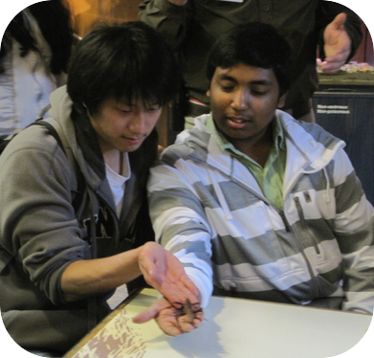
Once the volunteer has contacted their buddy and their family, regular meetings are organized. In addition to the one-on-one activities or outings that are the hallmark of the Beyond Me program, the executive team also hosts group events approximately once a month to which all mentors, buddies, and families are invited. In order to keep Beyond Me events as inclusive as possible, all events are either free or at a very low cost. These group events give the children in the program an opportunity to socialize and make new friends, try new skills, and be creative, while also giving mentors and parents an opportunity to network as well.

Past events hosted by Montreal Beyond Me include trips to the Biodome, Cosmic bowling, the Ecomuseum, Redpath Museum, the Science Centre, the Fine Arts Museum, and custom events hosted at McGill University, including Mad Science Day, Carnival Day, and “Messy Fun Day.”
Learning about bugs at the Insectarium!

Frequently Asked Questions:

Where does the volunteering take place?
All activities between matches will take place at a location determined by the mentor and the buddy or the parents of the child. Possible locations include the buddy’s school, the buddy’s home, local community centers, local libraries, and other child-friendly locations (i.e. the Biodome, a bowling alley, shopping mall, the park).
What are some examples of activities that mentors and buddies could do?

The types of activities matches pursue depend on both the interests of the mentor and the interests of the buddy. Some examples of the activities logged by volunteers this past year include baking cupcakes, homework help, reading books at the local library, swimming at the YMCA, apple picking, and arts and crafts at the buddy’s home. We encourage our volunteers to be creative with their outing and activity ideas to facilitate new experiences and opportunities for growth for their buddy!

What is the time commitment required of a Beyond Me volunteer?

All of the interactions between a mentor and a buddy are arranged to fit both the mentor’s schedule as well as that of the child and their parents, allowing for maximum flexibility. Beyond Me requires all mentors to complete a minimum of 8 hours per month volunteering with their buddy. However, those 8 hours can occur at any time during the month. Some volunteers like to get together with their buddy for two hours every weekend, and other matches meet less frequently during the month but spend longer periods of time together in those instances to ensure the required number of hours is completed.
How long does the mentor-buddy relationship last?

At minimum, we require that the volunteer maintain a relationship with their buddy for the duration of Western’s academic year; from the time they are matched until the end of April. Volunteers often continue the relationship throughout the summer and into the following academic year, and a number of Beyond Me matches have been together for years!
What is the level of experience of the volunteers matched through Beyond Me?

Beyond Me does not require our volunteers to have a background working with youth with disabilities. We simply require our volunteers to be flexible, open-minded individuals who are committed to the program with a readiness to learn and grow. However, the majority of our volunteers do have experience working with children and children with special needs, and all of our volunteers undergo training to enhance their understanding of the disabilities present in our program and in the basic strategies for mentoring youth with disabilities. All volunteers, regardless of their experience level, are also supported through continuous communication with the Beyond Me Executive Team. Beyond Me also carefully screens our volunteers through the application and interview process to ensure that the volunteer is placed with a buddy they are comfortable with and who complements their previous experience.

Contact Us!

For general inquiries or more information about the program, please feel free to contact us at BeyondMeLondon@gmail.com.

